**ADSA Session-3**

**1.) Best optimized code to check whether given number is prime or not.**

**Code:**

#include <iostream>

#include<cmath>

using namespace std;

int main() {

int n;

cout<<"Enter any number (to check whether it is prime or not):";

cin>>n;

int flag=0;

if(n!=2 && n%2==0){

flag = 1;

}

if(n!=3 && n%3==0){

flag = 1;

}

else{

for(int i=5; i<=sqrt(n); i+=6 ){

if(n%i==0 || n%(i+2)==0){

flag=1;

break;

}

}

}

if(flag==0)

cout<<"Given number is a prime Number";

else

cout<<"Given number is not Prime Number";

return 0;

}

**Output:**

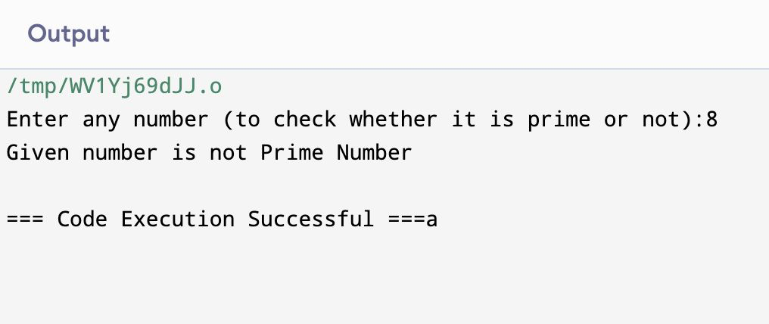

**2. Find sum of all prime numbers below that entered number(input).**

**Code:**

#include <iostream>

#include<cmath>

using namespace std;

int main() {

int n,sum;

cout<<"Enter any number: (which you want to find sum of all prime numbers below that entered number):"<<endl;

cin>>n;

for(int i = 2; i < n; i++){

int flag=0;

if(i!=2 && i%2==0){

flag = 1;

}

else if(i!=3 && i%3==0){

flag = 1;

}

else{

for(int j=5; i<=sqrt(i); j+=6 ){

if(i%j==0 || i%(j+2)==0){

flag=1;

break;

}

}

}

if(flag==0)

sum += i;

}

cout<<"sum of all prime numbers below "<<n<<" is "<<sum<<endl;

return 0;

}

**Output:**

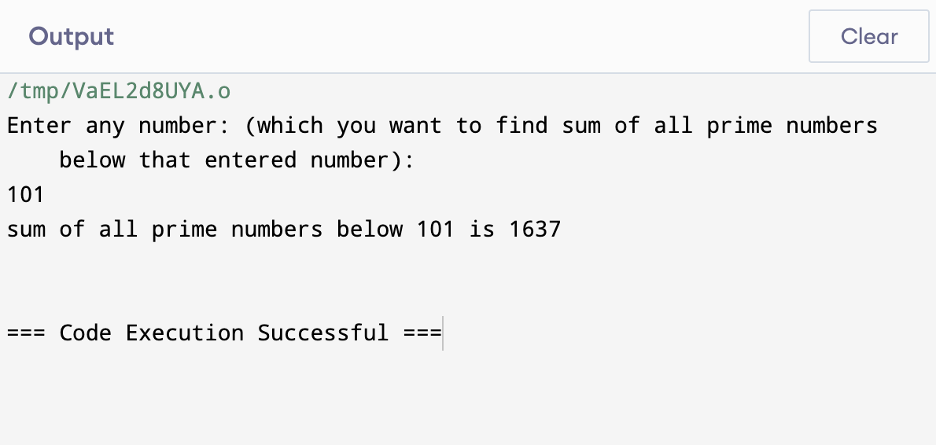

**3.) Pascal’s Triangle generator;**

**Code:**

#include <iostream>

using namespace std;

int main() {

int n;

cout<<"Enter a Number of rows to generate the Pascal's Triangle: ";

cin>>n;

int c;

for(int i = 0; i < n; i++){

c=1;

for(int j = 0; j <= i; j++){

if(i == 0 || j == 0)

cout<<1<<" ";

else{

c = c*(i-j+1)/j; //nCr = ((n-r+1)/r)*nCr-1

cout<<c<<" ";

}

}

cout<<endl;

}

return 0;

}

**Output:**

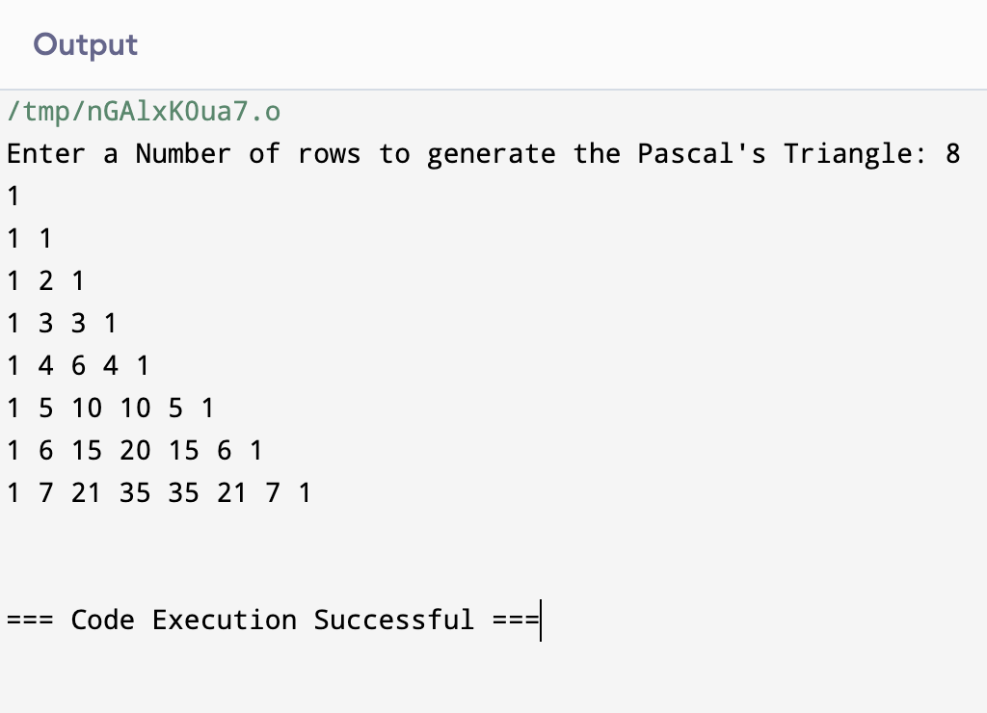

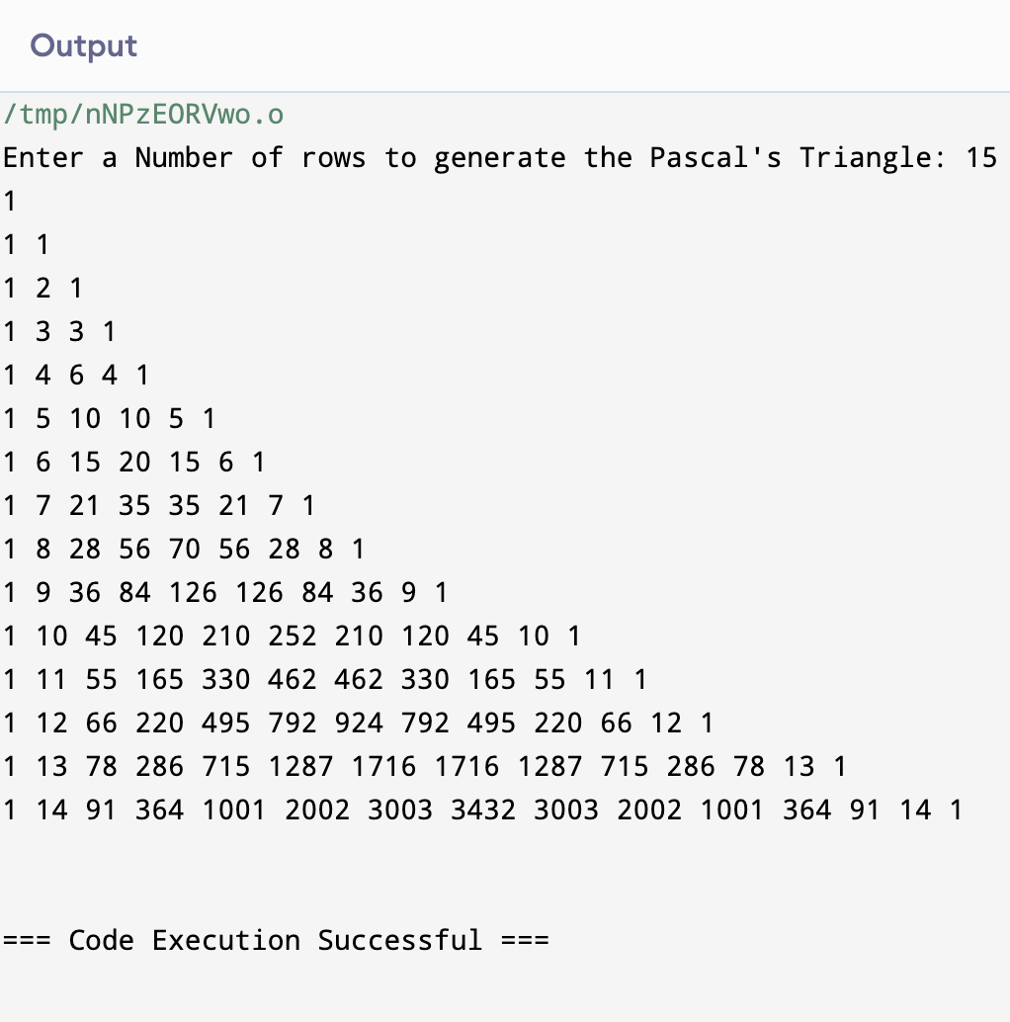

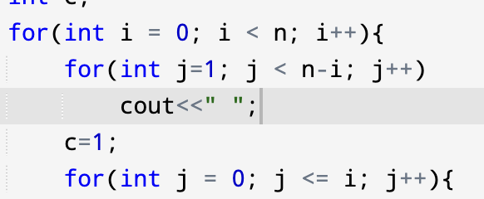

For this condition we align our pascal’s triangle as follows;

